A
Major Project Stage 2 Report
On

Automated Detection of Deep Fakes: A Deep learning Approach
Submitted to CMR ENGINEERING COLLEGE
In Partial Fulfillment of the requirements for the Award of Degree of

BACHELOR OF TECHNOLOGY IN
CSE-CYBER SECURITY
Submitted By

S.ANU PRIYA | (218R1A6253)
T.ARAVIND | (218R1A6258)
G.ROHITH REDDY | (218R1A6226)
CH.MANOJ SAI KUMAR | (218R1A6218)

Under the Esteemed guidance of

Mrs. M. Amrutha
Assistant Professor, Department of CSE-CS


Department of Computer Science & Engineering-Cyber Security
CMR ENGINEERING COLLEGE
UGC AUTONOMOUS
(Approved by AICTE, NEW DELHI, Affiliated to JNTU, Hyderabad) Kandlakoya, Medchal Road, R.R. Dist. Hyderabad-501 401)
2024-2025

CMR ENGINEERING COLLEGE
UGC AUTONOMOUS
(Accredited by NBA,Approved by AICTE NEW DELHI, Affiliated to JNTU, Hyderabad) Kandlakoya, Medchal Road, Hyderabad-501 401
Department of CSE-CYBER SECURITY

CERTIFICATE

This is to certify that the project entitled “Automated Detection of Deep Fakes: A Deep learning Approach” is a bonafide work carried out by

S.ANU PRIYA | (218R1A6253)
T.ARAVIND | (218R1A6258)
G.ROHITH REDDY | (218R1A6226)
CH.MANOJ SAI KUMAR | (218R1A6218)

in partial fulfillment of the requirement for the award of the degree of BACHELOR OF TECHNOLOGY in COMPUTER SCIENCE AND ENGINEERING-CYBER SECURITY from
CMR Engineering College, affiliated to JNTU, Hyderabad, under our guidance and supervision.
The results presented in this Major project have been verified and are found to be satisfactory. The results embodied in this Major project have not been submitted to any other university for the award of any other degree or diploma.

Internal Guide | Major Project Coordinator | Head of the Department
Mrs. M. Amrutha | Ms. T. Usha | Dr. M. Ashwitha Reddy
Assistant Professor | Assistant Professor | Associate Professor & H.OD
Department of CSE-CS, CMREC, Hyderabad | Department of CSE-CS, CMREC, Hyderabad | Department of CSE-CS, CMREC, Hyderabad

External Examiner

DECLARATION

This is to certify that the work reported in the present project entitled “Automated Detection of Deep Fakes: A Deep learning Approach” is a record of bonafide work carried out by us in the Department of Computer Science and Engineering (Cyber Security) at CMR Engineering College, JNTU Hyderabad. The report is based entirely on our project work and has not been copied from any other source. I submit this project for further development by any interested students who share similar interests, with the hope of enhancing the project in the future. To the best of our knowledge and belief, the results embodied in this project report have not been submitted to any other university or institute for the award of any degree or diploma.

S.ANUPRIYA | (218R1A6253)

ACKNOWLEDGMENT

We are extremely grateful to Dr. A. Srinivasula Reddy, Principal, and Dr. M. Ashwitha Reddy, Head of the Department of CSE - Cyber Security, CMR Engineering College, for their constant support.
We are deeply thankful to Mrs.M.Amrutha Assistant Professor and Internal Guide, for her unwavering guidance, encouragement, and moral support throughout the project.
We would be remiss if we did not acknowledge with gratitude the authors of the references and literature cited in this project.
We thank Ms. T. Usha, Assistant Professor and Major Project Coordinator, for her continuous support in carrying out project activities and reviews.
We express our thanks to all staff members and friends for their assistance and coordination in successfully completing this project on time.
Finally, we are very thankful to our parents for their guidance every step of the way.

S.ANU PRIYA | (218R1A6253)
T.ARAVIND | (218R1A6258)
G.ROHITH REDDY | (218R1A6226)
CH.MANOJ SAI KUMAR | (218R1A6218)

CONTENTS

TOPIC PAGENO
ABSTRACT i

LIST OF FIGURES ii
LIST OF TABLES iii
- INTRODUCTION
  - Introduction and Objectives 01
  - Purpose of the Project 02
  - Existing System and Disadvantages 03
  - Proposed System and Advantages 04
- LITERATURE SURVEY 05
- SOFTWARE REQUIREMENT ANALYSIS
  - Problem Specification 08
  - Functional Requirements 08
  - Non-Functional Requirements 09
  - Feasibility Study 10
- SOFTWARE AND HARDWARE REQUIREMENTS
  - Hardware Configuration 11
  - Software Configuration
- SOFTWARE DESIGN
  - Data Flow Diagrams 12
  - UML Diagrams 14
  - System Architecture 19
- CODING AND IMPLEMENTATION
  - Modules 20
  - Sample Code 21
- TESTING
  - Introduction of Testing 26
    - Static Testing 26
    - Structural Testing 27
    - Behavioural Testing 28
  - Test Cases 29
- OUTPUT SCREENS 32
- CONCLUSION 36
- FUTURE ENHANCEMENTS 37
- REFERENCES 38

ABSTRACT
This comprehensive study delves into the dynamic landscape of deep learning applications, focusing on the burgeoning realm of deep fakes. Deep learning has seamlessly integrated into fields like natural language processing, machine learning, and computer vision, giving rise to innovative applications. However, the surge in deep fakes, sophisticatedly manipulated videos/images, has become a pressing concern. The nefarious applications of this technology, such as fake news, celebrity impersonations, financial scams, and revenge porn, pose significant threats in the digital realm. Particularly, public figures like celebrities and politicians are highly susceptible to the Deep fake detection challenge. This research systematically assesses both the production and detection aspects of deep fakes, employing diverse deep learning algorithms, including InceptionResnetV2, VGG19, CNN, and Xception. The evaluation, conducted on a Kaggle deep fake dataset, highlights Xception as the most accurate among the algorithms studied. As malicious uses of deep fakes escalate, the imperative for robust detection mechanisms intensifies to safeguard against potential societal consequences.

 |  | LIST OF FIGURES
S. NO. | FIG. NO. | DESCRIPTION |  | PAGE NO.
1 | 5.1.1 | Data flow Diagram |  | 13
2 | 5.2.1 | Use Case Diagram |  | 15
3 | 5.2.2 | Class Diagram |  | 16
4 | 5.2.3 | Activity Diagram |  | 17
5 | 5.2.4 | Sequence Diagram |  | 18
6 | 5.3.1 | System Architecture |  | 19
7 | 7.1.1 | Static testing |  | 27
8 | 7.1.2 | Structural testing |  | 28
9 | 7.1.3 | Behavioural testing |  | 28
10 | 8.1 | Output Screenshot1 |  | 32
11 | 8.2 | Output Screenshot2 |  | 32
12 | 8.3 | Output Screenshot3 |  | 33
13 | 8.4 | Output Screenshot4 |  | 33
14 | 8.5 | Output Screenshot5 |  | 34
15 | 8.6 | Output Screenshot6 |  | 34
16 | 8.7 | Output Screenshot7 |  | 35
17 | 8.8 | Output Screenshot8 |  | 35

LIST OF TABLES

S NO | TABLE NO | TABLE NAME | PAGE NO
1  2  3  4 | 7.2.1  7.2.2  7.2.3  7.2.4 | User Registration Test Cases  Video Upload & Detection Test Cases  Detection Result & Report Test Cases Admin Panel Test Case | 29  30  30  31

INTRODUCTION

INTRODUCTION AND OBJECTIVES
In the contemporary era of rapid technological advancement, the human face has transcended its traditional role as a mere physical feature to become a powerful symbol of identity, trust, and personal authenticity. Facial identity is not only central to personal recognition and emotional communication but also forms the cornerstone of various critical domains, including law enforcement, national security, financial transactions, and digital authentication systems. However, as technology progresses at an unprecedented pace, the very essence of facial identity is facing an existential threat. The emergence and evolution of sophisticated face synthesis technologies have disrupted the long- standing sanctity of personal identity, giving rise to alarming possibilities for its manipulation and exploitation.
Among these technologies, deep fake stands out as a particularly formidable and concerning innovation. Powered by advanced artificial intelligence (AI) and machine learning algorithms, deep fake technology enables the seamless and highly realistic superimposition of one individual's face onto another's body in videos, images, and audio-visual content. What makes deep fakes especially dangerous is not only the technical brilliance behind their creation but also the ease and speed with which they can be generated and disseminated. More troubling is that these synthetic representations are often produced without the consent or knowledge of the individuals involved, infringing upon their privacy, dignity, and reputation. The potential misuse of deep fake content spans a vast spectrum—from defamation, political manipulation, and financial fraud to cyberbullying and identity theft, thus posing a serious threat not only to individuals but to the very fabric of society.
The implications of such unauthorized facial alterations go far beyond personal privacy violations, shaking the foundations of public trust in visual media and undermining the authenticity of digital evidence. In an age where seeing is believing, deep fakes challenge our very ability to distinguish between reality and fabrication. This raises grave concerns for national security, democratic processes, judicial systems, and social harmony, making it imperative to develop robust mechanisms for detecting and mitigating such synthetic content.
At the forefront of this global battle against deep fake technology lies the remarkable field of deep learning—a branch of AI inspired by the workings of the human brain. Deep learning has already revolutionized various sectors, including healthcare, autonomous systems, natural language processing, and computer vision. Its unparalleled ability to learn from massive datasets, recognize intricate patterns, and adapt to evolving challenges makes it a powerful ally in detecting and

countering deep fake threats. By leveraging convolutional neural networks (CNNs), recurrent neural networks (RNNs), generative adversarial networks (GANs), and transformer architectures, deep learning-based systems are being designed to identify even the most subtle anomalies and artifacts present in deep fake media.
Furthermore, deep learning plays a critical role not only in detecting deep fakes but also in developing proactive strategies for prevention, authentication, and content verification. Its integration into security infrastructures and digital platforms holds the promise of reinforcing public confidence in media content, thereby safeguarding personal identities and upholding social trust. The fusion of artificial intelligence and cybersecurity through deep learning embodies the innovative and ethical use of technology to combat its own unintended consequences.
Thus, in this complex landscape where technology becomes both the tool and the challenge, deep learning emerges as a beacon of hope—a transformative force committed to preserving the integrity of human identity in the digital age. Through continued research, collaboration, and innovation, deep learning not only addresses the immediate threats posed by deep fakes but also paves the way for a safer, more secure, and trustworthy digital future.

PURPOSE OF THE PROJECT
This study delves into the application of deep learning techniques to address the escalating concern of deep fakes—manipulated videos and images that threaten personal identity, privacy, and public trust. With the rapid advancement of face synthesis technologies and the increasing misuse of deep fakes in spreading misinformation, conducting scams, and breaching privacy, there arises an urgent need for effective and reliable detection mechanisms.
To tackle this pressing issue, the research investigates and compares the performance of several cutting-edge deep learning algorithms, including InceptionResNetV2, VGG19, Convolutional Neural Networks (CNN), and Xception, utilizing a comprehensive deep fake dataset sourced from Kaggle. Through an in-depth analysis of these models, the study aims to evaluate their ability to discern between authentic and manipulated facial content.
The findings of this research highlight the critical role of deep learning in fortifying digital security systems and mitigating the risks associated with deep fake technology. By examining various algorithmic approaches, the study underscores the importance of developing robust, accurate, and scalable solutions to safeguard individuals and society from the adverse impacts of malicious synthetic media. Ultimately, this work contributes to the ongoing efforts in preserving the integrity of digital communications and protecting the fundamental right to identity in the age of AI-driven media manipulation.

EXISTING SYSTEM AND DISADVANTAGES
The existing system focuses on the analysis and utilization of previously deployed deep fake detection algorithms. It extensively explores classic detection methods and contemporary deep learning-based approaches, including Convolutional Neural Networks (CNN), Recurrent Neural Networks (RNN), and Long Short-Term Memory (LSTM). Classic methods often rely on rulebased heuristics, while deep learning methods harness the hierarchical learning capabilities of neural networks to discern intricate patterns indicative of deep fakes. The study aims to provide a comprehensive understanding of the strengths and limitations of these methods in identifying manipulated content. In contrast, the proposed system takes a proactive stance by integrating cutting-edge deep learning algorithms. The proposed system aims to enhance detection accuracy, contributing to a deeper comprehension of deep fake production and distribution for more effective countermeasures.
Disadvantages:
The existing system relies on both traditional and contemporary methods.
- This reliance can limit adaptability to new deep fake techniques.
- Classic methods depend on rule-based heuristics.
- These methods may struggle with the sophistication of evolving deep fake creation.
- This can lead to decreased accuracy in detection.
- Deep learning methods are used.
- However, the system may lack a comprehensive understanding of the complex patterns in new deep fake technologies.

PROPOSED SYSTEM AND ADVANTAGES
The proposed system aims to combat the escalating threat of deep fakes through an integrated approach leveraging cutting-edge deep learning algorithms. Utilizing a Kaggle deep fake dataset, our system employs InceptionResnetV2, VGG19, CNN, and Xception algorithms for comprehensive evaluation. The emphasis is on developing a robust detection mechanism to discern authentic content from manipulated ones. By scrutinizing the intricacies of deep fakes, the system aspires to contribute to a deeper understanding of their production and distribution. The integration of multiple algorithms ensures a nuanced analysis, while the dataset provides a diverse range of scenarios for effective training and testing. This holistic approach seeks to enhance the overall accuracy and reliability of

deep fake detection, mitigating the potential societal consequences of fake news, impersonations, and privacy violations. The proposed system stands as a pivotal tep 4

Advantages of Proposed System:
- The proposed system integrates advanced algorithms like InceptionResnetV2 and Xception, enhancing its capability to detect sophisticated deep fake manipulations effectively.

- Utilizing multiple algorithms facilitates a nuanced analysis, ensuring a robust detection mechanism capable of discerning authentic content from manipulated instances.

- The system benefits from a Kaggle deep fake dataset, providing a diverse range of scenarios for training and testing, enhancing its adaptability to real-world situations.

- The proposed system takes a holistic approach, aiming not only to enhance accuracy but also to deepen comprehension of deep fake production, distribution, and societal consequences, offering a more proactive defense strategy.

LITERATURE SURVEY
The method we propose in this paper is closely related to four broader areas of research, namely deep learning techniques for image and video analysis, various neural network architectures, deep learning- based detection systems, and several studies on deep fake detection that analyzed the performance metrics such as accuracy and precision.

1 .WildDeepfake: A Challenging Real-World Dataset for Deepfake Detection: WildDeepfake:
A Challenging Real-World Dataset for Deepfake Detection .In recent years, the abuse of a face swap technique called deepfake has raised enormous public concerns. So far, a large number of deepfake videos (known as "deepfakes") have been crafted and uploaded to the internet, calling for effective countermeasures. One promising countermeasure against deep fakes is deep fake detection. Several deepfake datasets have been released to support the training and testing of deepfake detectors, such as Deep fake Detection and Face Forensics. While this has greatly advanced deepfake detection, most of the real videos in these datasets are filmed with a few volunteer actors in limited scenes, and the fake videos are crafted by researchers using a few popular deepfake softwares. Detectors developed on these datasets may become less effective against real-world deepfakes on the internet. To better support detection against real-world deepfakes, in this paper, we introduce a new dataset WildDeepfake, which consists of 7,314 face sequences extracted from 707 deepfake videos collected completely from the internet. WildDeepfake is a small dataset that can be used, in addition to existing datasets, to develop and test the effectiveness of deepfake detectors against real-world deepfakes. We conduct a systematic evaluation of a set of baseline detection networks on both existing and our WildDeepfake datasets, and show that WildDeepfake is indeed a more challenging dataset, where the detection performance can decrease drastically. We also propose two (eg. 2D and 3D) Attention-based Deepfake Detection Networks (ADDNets) to leverage the attention masks on real/fake faces for improved detection. We empirically verify the effectiveness of ADDNets on both existing datasets and WildDeepfake

Learning Self-Consistency for Deepfake Detection:

We propose a new method to detect deepfake images using the cue of the source feature inconsistency within the forged images. It is based on the hypothesis that images’ distinct source features can be preserved and extracted after going through state-of-the-art deepfake generation processes. We

introduce a novel representation learning approach, called pair-wise self-consistency learning (PCL), for training ConvNets to extract these source features and detect deepfake images. It is accompanied by a new image synthesis approach, called inconsistency image genera-tor, to provide richly annotated training data for PCL. Experimental results on seven popular datasets show that our models improve averaged AUC over the state of the art from 96.45% to 98.05% in the in- dataset evaluation and from 86.03% to 92.18% in the cross-dataset evaluation

- Detecting Deepfake Videos using Attribution-Based Confidence Metric:
Recent advances in generative adversarial networks have made detecting fake videos a challenging task. In this paper, we propose the application of the state-of-the-art attribution based confidence ABC metric for detecting deepfake videos. The ABC metric does not require access to the training data or training the calibration model on the validation data. The ABC metric can be used to draw inferences even when only the trained model is available. Here, we utilize the ABC metric to characterize whether a video is original or fake. The deep learning model is trained only on original videos. The ABC metric uses the trained model to generate confidence values. For, original videos, the confidence values are greater than 0.94. By utilizing the ABC metric, our system offers a novel, efficient, and scalable solution to the deep fake detection problem. This approach eliminates the need for retraining on manipulated videos and provides a confidence-driven mechanism for assessing authenticity. As deep fake technologies continue to evolve, leveraging advanced confidence-based metrics like ABC will be crucial in safeguarding digital content and mitigating the risks associated with synthetic media.

Adversarial Perturbations Fool Deepfake Detectors:
This work uses adversarial perturbations to enhance deepfake images and fool common deepfake detectors. We created adversarial perturbations using the Fast Gradient Sign Method and the Carlini and Wagner L 2 norm attack in both blackbox and whitebox settings. Detectors achieved over 95% accuracy on unperturbed deepfakes, but less than 27% accuracy on perturbed deepfakes. We also explore two improvements to deep-fake detectors: Lipschitz regularization, and (Deep Image Prior DIP. Lipschitz regularization constrains the gradient of the detector with respect to the input in order to increase robustness to input perturbations. The DIP defense removes perturbations using generative convolutional neural networks in an unsupervised manner. Regularization improved the detection of perturbed deepfakes on average, including a 10% accuracy boost in the blackbox case. The DIP defense achieved 95% accuracy on perturbed deepfakes that fooled the original detector while retaining 98% accuracy in other cases on a 100 image subsample.

DeepfakeStack: A Deep Ensemble-based Learning Technique for Deepfake Detection:
Recent advances in technology have made the deep learning models available for use in a wide variety of novel applications; for example, generative adversarial network models are capable of producing hyper realistic images, speech, and even videos, such as the so-called “Deepfake” produced by GANs with manipulated audio and/or video clips, which are so realistic as to be indistinguishable from the real ones in human perception. Aside from innovative and legitimate applications, there are numerous nefarious or unlawful ways to use such counterfeit contents in propaganda, political campaigns, cybercrimes, extortion, etc. To meet the challenges posed by Deepfake multimedia, we propose a deep ensemble learning technique called DeepfakeStack for detecting such manipulated videos. The proposed technique combines a series of DL based state-of- art classification models and creates an improved composite classifier. Based on our experiments, it is shown that DeepfakeStack outperforms other classifiers by achieving an accuracy of 99.65% and AUROC of 1.0 score in detecting Deepfake.

SOFTWARE REQUIREMENT ANALYSIS

PROBLEM SPECIFICATION
The proliferation of deep fakes, convincingly altered videos/images, poses a grave threat in various domains, including misinformation dissemination and privacy breaches. This study addresses the pressing need to comprehend and counteract the malicious applications of deep fakes, emphasizing the urgency in developing effective detection methodologies.

FUNCTIONAL REQUIREMENTS
- Data Collection
- Image processing
- Training and Testing 4.Modelling 5.Predicting

NON FUNCTIONAL REQUIREMENTS
NON-FUNCTIONAL REQUIREMENT (NFR) specifies the quality attribute of a software system. They judge the software system based on Responsiveness, Usability, Security, Portability and other non-functional standards that are critical to the success of the software system. Example of nonfunctional requirement, “how fast does the website load?” Failing to meet non-functional requirements can result in systems that fail to satisfy user needs. Non- functional Requirements allow you to impose constraints or restrictions on the design of the system across the various agile backlogs. Example, the site should load in 3 seconds when the number of simultaneous users is > 10000. Description of non-functional requirements is just as critical as a functional requirement.
- Usability requirement
- Serviceability requirement

- Manageability requirement

- Recoverability requirement

- Security requirement

- Data Integrity requirement

- Capacity requirement

- Availability requirement

- Scalability requirement

- Interoperability requirement

- Reliability requirement

- Maintainability requirement

- Environmental requirement

FEASIBILITY STUDY
The feasibility of the project is analyzed in this phase and business proposal is put forth with a very general plan for the project and some cost estimates. During system analysis the feasibility study of the proposed system is to be carried out. This is to ensure that the proposed system is not a burden to the company. For feasibility analysis, some understanding of the major requirements for the system is essential.
Three key considerations involved in the feasibility analysis are
- Economical Feasibility
- Technical Feasibility
- Social Feasibiity

Economical Feasibility
This study is carried out to check the economic impact that the system will have on the organization. The amount of fund that the company can pour into the research and development of the system is limited. The expenditures must be justified. Thus the developed system as well within the budget and this was achieved because most of the technologies used are freely available. Only the customized products had to be purchased.

Technical Feasibility
This study is carried out to check the technical feasibility, that is, the technical requirements of the system. Any system developed must not have a high demand on the available technical resources. This will lead to high demands on the available technical resources. This will lead to high demands being placed on the client. The developed system must have a modest requirement, as only minimal or null changes are required for implementing this system.

Social Feasibility
The aspect of study is to check the level of acceptance of the system by the user. This includes the process of training the user to use the system efficiently. The user must not feel threatened by the system, instead must accept it as a necessity. The level of acceptance by the users solely depends on the methods that are employed to educate the user about the system and to make him familiar with it. His level of confidence must be raised so that he is also able to make some constructive criticism, which is welcomed, as he is the final user of the system.
User acceptance is a crucial factor in determining the success of a system. A system may be technically sound and functionally rich, but if users do not accept it, its implementation will likely fail. Ensuring user acceptance involves comprehensive training, a user-friendly interface, and effective communication. Training sessions should be tailored to different user groups based on their expertise levels, helping them gain confidence in using the system. The system should also have an intuitive and user-friendly interface to minimize the learning curve, as a complex system with difficult navigation can discourage users. Additionally, effective communication is essential to keep users informed about the system’s benefits, functionalities, and updates, ensuring a smooth transition. Users must not feel threatened by the system but should see it as a necessity. Their confidence should be raised so that they can provide constructive criticism, which is welcomed, as they are the final users of the system. The success of user acceptance ultimately depends on the methods employed to educate and familiarize users with the system, making their transition seamless and efficient.

SOFTWARE AND HARDWARE REQUIREMENTS

SOFTWARE REQUIREMENTS
- Software : Anaconda
- Primary Language : Python
- Frontend Framework : Flask
- Back-end Framework : Jupiter Notebook
- Database : Sqlite3
- Front-End Technologies : HTML, CSS, JavaScript and Bootstrap4

HARDWARE REQUIREMENTS
  - Operating System : Windows Only
  - Processor : i5 and above
  - Ram : 8gb and above
  - Hard Disk : 25 GB in local drive

SOFTWARE DESIGN

DATAFLOW DIAGRAMS

- The DFD is also called as bubble chart. It is a simple graphical formalism that can be used to represent a system in terms of input data to the system, various processing carried out on this data, and the output data is generated by this system.
- The data flow diagram (DFD) is one of the most important modeling tools. It is used to model the system components. These components are the system process, the data used by the process, an external entity that interacts with the system and the information flows in the system. . It is a graphical technique that depicts information flow and the transformations that are applied as data moves from input to output.
- A Data Flow Diagram (DFD) is a visual tool that illustrates the flow of data within a system, showcasing its processes, data inputs, outputs, and interactions with external entities. It uses a set of symbols to represent these elements, such as circles or rounded rectangles for processes, arrows for data flows, open-ended rectangles for data stores, and rectangles for external entities. The hierarchical nature of DFDs allows for multiple levels of detail, starting with an overview (Level 0) and breaking down into more detailed diagrams (Level 1, Level 2, etc.) as needed. These diagrams serve as a bridge between technical and non-technical stakeholders, enabling clear communication and understanding of a system’s functionality. DFDs are valuable for analyzing the flow of information, identifying system inefficiencies, and assisting in the design and improvement of systems. By maintaining simplicity, using meaningful labels, and avoiding clutter, DFDs become a powerful tool for system analysis and design.
- By structuring DFDs hierarchically, starting from a broad context diagram to detailed subprocesses, organizations can progressively dissect their systems for better design and optimization. Furthermore, the use of intuitive symbols ensures that even non-technical individuals can grasp the system's inner workings, making DFDs a cornerstone of effective system design and analysis.

Import libraries
Yes
NO
VERIFY
End process
Final outcome
User input
Signup & sign in
Training the model
Building the model - InceptionResnetV2 - VGG19 - CNN - Xception
Data visualization
Image processing
Exploring the dataset
NO PROCESS
    - data flow diagram

UML DIAGRAMS:
UML stands for Unified Modelling Language. UML is a standardized general purpose modelling language in the field of object-oriented software engineering. The standard is managed, and was created by, the Object Management Group.
The goal is for UML to become a common language for creating models of object- oriented computer software. In its current form UML is comprised of two major components: a Meta- model and a notation. In the future, some form of method or process may also be added to; or associated with, UML.
The Unified Modelling Language is a standard language for specifying, Visualization, Constructing and documenting the artifacts of software system, as well as for business modelling and other nonsoftware systems.
The UML represents a collection of best engineering practices that have proven successful in the modelling of large and complex systems.
The UML is a very important part of developing objects oriented software and the software development process. The UML uses mostly graphical notations to express the design of software projects.

GOALS:
The Primary goals in the design of the UML are as follows:

- Provide users a ready-to-use, expressive visual modelling Language so that they can develop and exchange meaningful models.
- Provide extendibility and specialization mechanisms to extend the core concepts.
- Be independent of particular programming languages and development process.
- Provide a formal basis for understanding the modelling language.
- Encourage the growth of OO tools market.
- Support higher level development concepts such as collaborations, frameworks, patterns and components.

Use Case Diagram:
A use case diagram in the Unified Modelling Language (UML) is a type of behavioural diagram defined by and created from a Use-case analysis. Its purpose is to present a graphical overview of the functionality provided by a system in terms of actors, their goals (represented as use cases), and any dependencies between those use cases. The main purpose of a use case diagram is to show what system functions are performed for which actor. Roles of the actors in the system can be depicted.

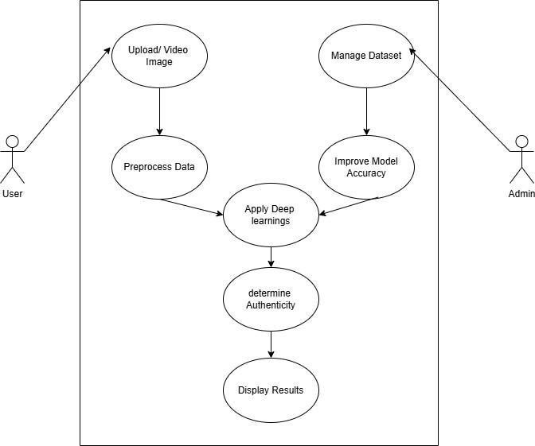

Figure 5.2.1 Use Case Diagram

Class Diagram:

The class diagram is used to refine the use case diagram and define a detailed design of the system. The class diagram classifies the actors defined in the use case diagram into a set of interrelated classes. The relationship or association between the classes can be either an "is- a" or "has-a" relationship. Each class in the class diagram may be capable of providing certain functionalities. These
functionalities provided by the class are termed "methods" of the class. Apart from this, each class may have certain "attributes" that uniquely identify the class.
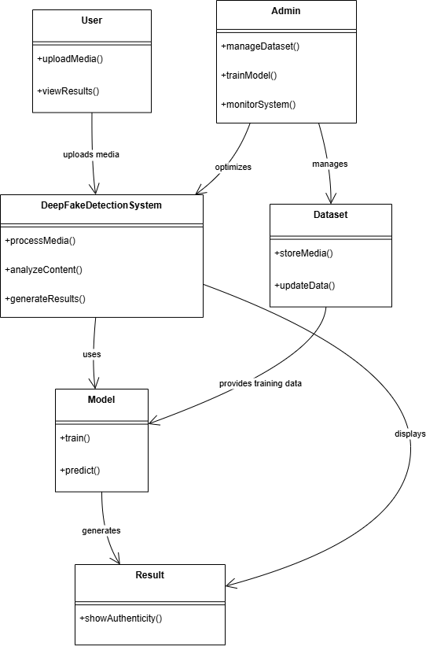

Figure 5.2.2 Class Diagram

Activity Diagram:

The process flows in the system are captured in the activity diagram. Similar to a state diagram, an activity diagram also consists of activities, actions, transitions, initial and final states, and guard conditions.

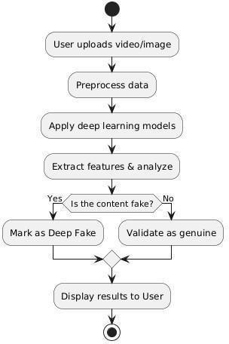
Figure 5.2.3 Activity Diagram

Sequence Diagram:

A sequence diagram represents the interaction between different objects in the system. The important aspect of a sequence diagram is that it is time-ordered. This means that the exact sequence of the interactions between the objects is represented step by step. Different objects in the sequence diagram interact with each other by passing "messages".

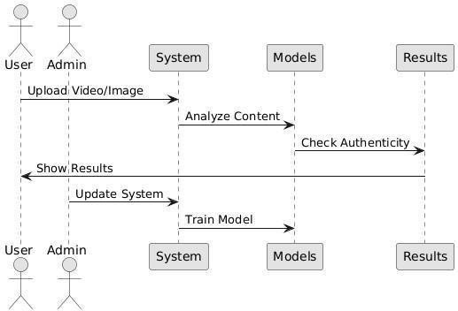

Figure 5.2.4 Sequence Diagram.

SYSTEM ARCHITECTURE

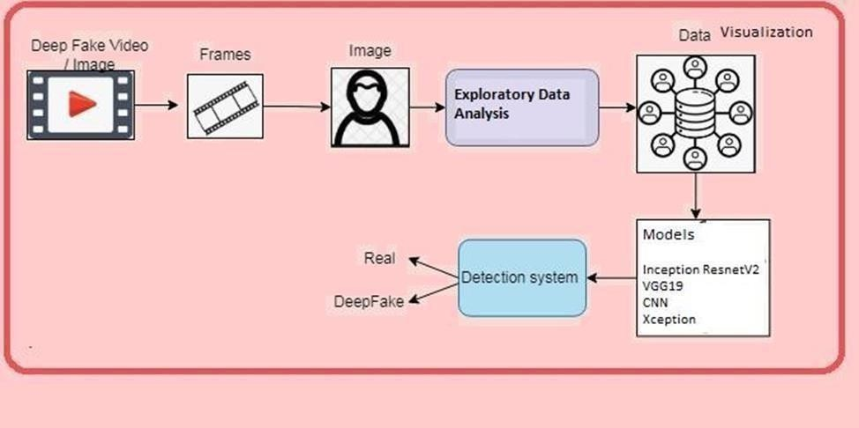

    - System Architecture

CODING AND IMPLEMENTATION

MODULES:

Data exploration: using this module we will load data into system

Image processing: Using the module we will process of transforming an image into a digital form and performing certain operations to get some useful information from it.
Splitting data into train & test: using this module data will be divided into train & test

Model generation: Model building - InceptionResnetV2 - VGG19 - CNN - Xception. Algorithms accuracy is calculated.
User signup & login: Using this module will get registration and login User input: Using this module will give input for prediction Prediction: final predicted displayed

Algorithms:

Inception ResNetV2: Inception-ResNet-v2 is a convolutional neural architecture that builds on the Inception family of architectures but incorporates residual connections (replacing the filter concatenation stage of the Inception architecture).
VGG19: VGG-19 is a convolutional neural network that is 19 layers deep. You can load a pretrained version of the network trained on more than a million images
from the ImageNet database . The pretrained network can classify images into 1000 object categories, such as keyboard, mouse, pencil, and many animals.
CNN: A Convolutional Neural Network (CNN) is a type of deep learning algorithm that is particularly well-suited for image recognition and processing tasks. It is made up of multiple layers, including convolutional layers, pooling layers, and fully connected layers.
Xception: Xception is a convolutional neural network that is 71 layers deep. You can load a pretrained version of the network trained on more than a million images from the ImageNet database. The pretrained network can classify images into 1000 object categories, such as keyboard, mouse, pencil, and many animals.

SAMPLE CODE:

import numpy as np import pandas as pd import seaborn as sns
import matplotlib.pyplot as plt import tensorflow as tf
from tensorflow.keras.models import Sequential
from tensorflow.keras.layers import Conv2D, MaxPooling2D, Flatten, Dense, Dropout from tensorflow.keras.preprocessing.image import ImageDataGenerator
from sklearn.metrics import confusion_matrix, classification_report import os

# Data Preprocessing
# ImageDataGenerator is used to rescale images and split them into training and validation sets # Data Augmentation added to improve model generalization

datagen = ImageDataGenerator( rescale=1./255,
validation_split=0.2, # 20% of data is used for validation rotation_range=20,
width_shift_range=0.2, height_shift_range=0.2, shear_range=0.2, zoom_range=0.2, horizontal_flip=True, fill_mode='nearest'
)

# Load Training Data
train_data = datagen.flow_from_directory( 'dataset/',

target_size=(128, 128), batch_size=32, class_mode='binary', subset='training'
)

# Load Validation Data
val_data = datagen.flow_from_directory( 'dataset/',
target_size=(128, 128), batch_size=32, class_mode='binary', subset='validation'
)

# Model Definition model = Sequential([
Conv2D(32, (3,3), activation='relu', input_shape=(128,128,3)), MaxPooling2D(2,2),
Conv2D(64, (3,3), activation='relu'), MaxPooling2D(2,2),
Flatten(),
Dense(128, activation='relu'), Dropout(0.5),
Dense(1, activation='sigmoid')
])

# Model Compilation
model.compile(optimizer='adam', loss='binary_crossentropy', metrics=['accuracy'])

# Training the Model epochs = 10

history = model.fit(train_data, validation_data=val_data, epochs=epochs)

# Extracting training results acc = history.history['accuracy']
val_acc = history.history['val_accuracy'] loss = history.history['loss']
val_loss = history.history['val_loss']

# Plot Training & Validation Accuracy plt.figure(figsize=(12,6)) plt.subplot(1,2,1)
plt.plot(range(epochs), acc, label='Train Accuracy', color='blue') plt.plot(range(epochs), val_acc, label='Validation Accuracy', color='red') plt.xlabel('Epochs')
plt.ylabel('Accuracy') plt.legend()
plt.title('Training vs Validation Accuracy')

# Plot Training & Validation Loss plt.subplot(1,2,2)
plt.plot(range(epochs), loss, label='Train Loss', color='blue') plt.plot(range(epochs), val_loss, label='Validation Loss', color='red') plt.xlabel('Epochs')
plt.ylabel('Loss') plt.legend()
plt.title('Training vs Validation Loss') plt.show()
# Save Model model.save('deepfake_model.h5')

# Model Summary print(model.summary())

# Testing Model on a Sample Image
from tensorflow.keras.preprocessing import image

img_path = 'test_sample.jpg' # Change this to your test image path img = image.load_img(img_path, target_size=(128, 128)) img_array = image.img_to_array(img)
img_array = np.expand_dims(img_array, axis=0) / 255.0

# Prediction
prediction = model.predict(img_array)[0][0] print("Prediction Score:", prediction)

if prediction > 0.5: print("Deepfake Detected")
else:
print("Real Image")

# Confusion Matrix Evaluation y_true = []
y_pred = []

for images, labels in val_data: preds = model.predict(images) y_true.extend(labels)
y_pred.extend([1 if p > 0.5 else 0 for p in preds]) if len(y_true) >= val_data.samples:
break
prediction = model.predict(img_array)[0][0] print("Prediction Score:", prediction)

cm = confusion_matrix(y_true, y_pred) sns.heatmap(cm, annot=True, fmt='d', cmap='Blues') plt.xlabel('Predicted')
plt.ylabel('Actual') plt.title('Confusion Matrix') plt.show()

print("Classification Report:") print(classification_report(y_true, y_pred))

SYSTEM TESTING

INTRODUCTION TO TESTING
System testing, also referred to as system-level tests or system-integration testing, is the process in which a quality assurance (QA) team evaluates how the various components of an application interact together in the full, integrated system or application. System testing verifies that an application performs tasks as designed. This step, a kind of black box testing, focuses on the functionality of an application. System testing, for example, might check that every kind of user input produces the intended output across the application.

Phases of system testing:
A video tutorial about this test level. System testing examines every component of an application to make sure that they work as a complete and unified whole. A QA team typically conducts system testing after it checks individual modules with functional or user-story testing and then each component through integration testing.
If a software build achieves the desired results in system testing, it gets a final check via acceptance testing before it goes to production, where users consume the software. An app-dev team logs all defects, and establishes what kinds and amount of defects are tolerable.

Software Testing Strategies:
Optimization of the approach to testing in software engineering is the best way to make it effective. A software testing strategy defines what, when, and how to do whatever is necessary to make an endproduct of high quality. Usually, the following software testing strategies and their combinations are used to achieve this major objective:

Static Testing:
The early-stage testing strategy is static testing: it is performed without actually running the developing product. Basically, such desk-checking is required to detect bugs and issues that are present in the code itself. Such a check-up is important at the pre-deployment stage as it helps avoid problems caused by errors in the code and software structure deficits.

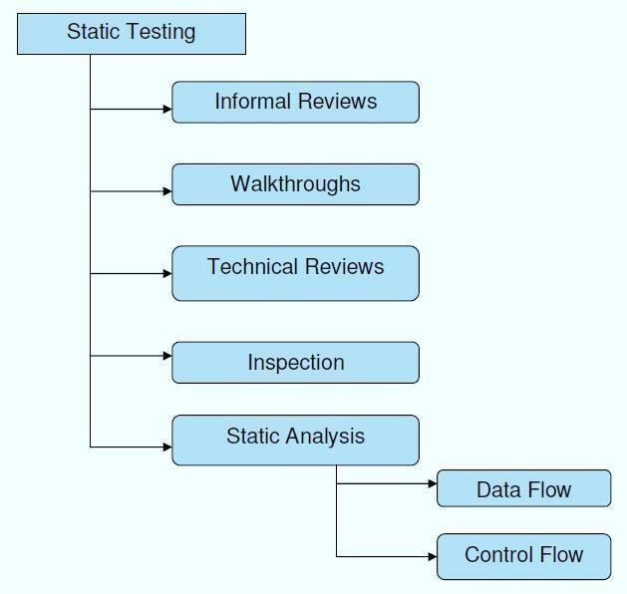

Fig 7.1.1 Static testing

Structural Testing:
It is not possible to effectively test software without running it. Structural testing, also known as white- box testing, is required to detect and fix bugs and errors emerging during the pre-production stage of the software development process. At this stage, unit testing based on the software structure is performed using regression testing. In most cases, it is an automated process working within the test automation framework to speed up the development process at this stage. Developers and QA engineers have full access to the software’s structure and data flows (data flows testing), so they could track any changes (mutation testing) in the system’s behavior by comparing the tests’ outcomes with the results of previous iterations (control flow testing).

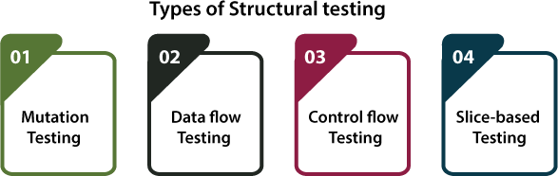

Fig 7.1.2 Structural testing

Behavioral Testing:
The final stage of testing focuses on the software’s reactions to various activities rather than on the mechanisms behind these reactions. In other words, behavioral testing, also known as black-box testing, presupposes running numerous tests, mostly manual, to see the product from the user’s point of view. QA engineers usually have some specific information about a business or other purposes of the software (‘the black box’) to run usability tests, for example, and react to bugs as regular users of the product will do. Behavioral testing also may include automation (regression tests) to eliminate human error if repetitive activities are required. For example, you may need to fill 100 registration forms on the website to see how the product copes with such an activity, so the automation of this test is preferable.
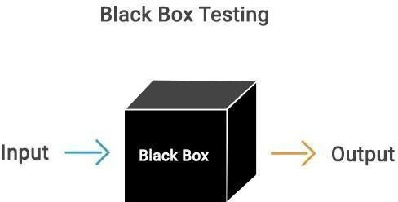

Fig 7.1.3 Behavioural testing

TEST CASES:

Test Case ID | Test Scenario | Test Steps | Expected Output | Result
UR-01 | Register a new user with valid details | - Open registration page  - Enter name, email,  - password  - Upload valid profile image  - Click "Register" | User registered successfully | Pass
UR-02 | Register with an already registered email | - Enter existing email  - Click "Register" | Error: "Email already registered" | Pass
UR-03 | Upload invalid image format | - Select a .txt file as image  - Click "Upload" | Error: "Invalid image format. Please upload .jpg or .png" | Pass
UR-04 | Leave mandatory fields empty | - Leave name or email field empty  - Click "Register" | Error: "All fields are required" | Pass
UR-05 | Check user data stored securely in DB | - Complete registration  - Check DB | User data stored securely in DB | Pass

Table-7.2.1 User Registration Test Cases

Test Case  ID | Test Scenario | Test Steps | Expected Output | Result
VD-01 | Upload  valid video for detection | - Lo gi n  - Upload valid video file  - Click "Detect" | Detection starts and shows result | Pass
VD-02 | Upload invalid file format | - Login  - Upload .txt or .doc file  - Click "Detect" | Error: "Invalid video format. Please upload  .mp4 or .avi" | Pass

VD-03 | Upload deepfake video | - Login  - Upload deepfake video  - Click "Detect" | Output: "Deepfake detected" | Pass
VD-04 | Upload genuine video | - Login  - Upload genuine video  - Click "Detect" | Output: "No Deepfake detected" | Pass
VD-05 | Try detection without uploading video | - Login  - Click "Detect" without upload | Error: "Please upload a video first" | Pass

Table-7.2.2 Video Upload & Detection Test Cases

Test Case ID | Test Scenario | Test Steps | Expected Result | Result
DR-01 | View detection report | - Upload video  - Click "View Report" | Report displayed with detection result and percentage | Pass
DR-02 | Download detection repo | r1t. Complete detection  2. Click "Download Report" | PDF Report downloaded | Pass
DR-03 | Check detection accuracy | - Upload multiple videos  - Compare output with known results | Accuracy matches expected output | Pass

Table-7.2.3 Detection Result & Report Test Cases

Test Case ID | Test Scenario | Test Steps | Expected Result | Result
AP-01 | Login as admin | - Enter admin credentials  - Click "Login" | Admin dashboard opens | Pass
AP-02 | View user activity | - Login as admin  - Open "User Activity" | User activity log is displayed | Pass
AP-03 | Delete user uploaded video | - Login as admin  - Select video  - Click "Delete" | Video deleted successfully | Pass
AP-04 | View overall detection stats | - Login as admin  - Open "Detection Stats" | Graph or report of detection history displayed | Pass

Table-7.2.4 Admin Panel Test Case

OUTPUT SCREENS

STEP-1


Fig-8.1 Homepage

STEP-2

Fig-8.2 Admin Login Screen

STEP-3


Fig-8.3 Admin Page

STEP-4


Fig-8.4 Upload Image

STEP-5
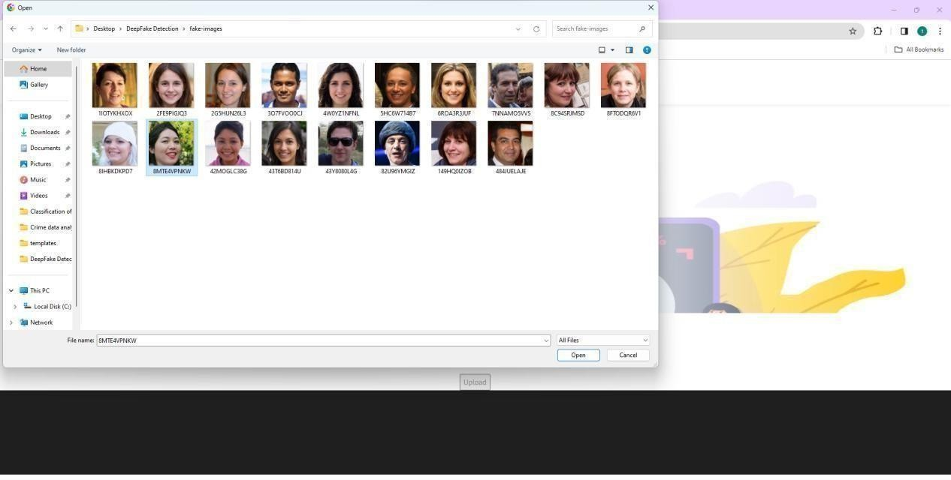

Fig-8.5 Select Image
STEP-6



Fig-8.6 Result for given input1

STEP-7

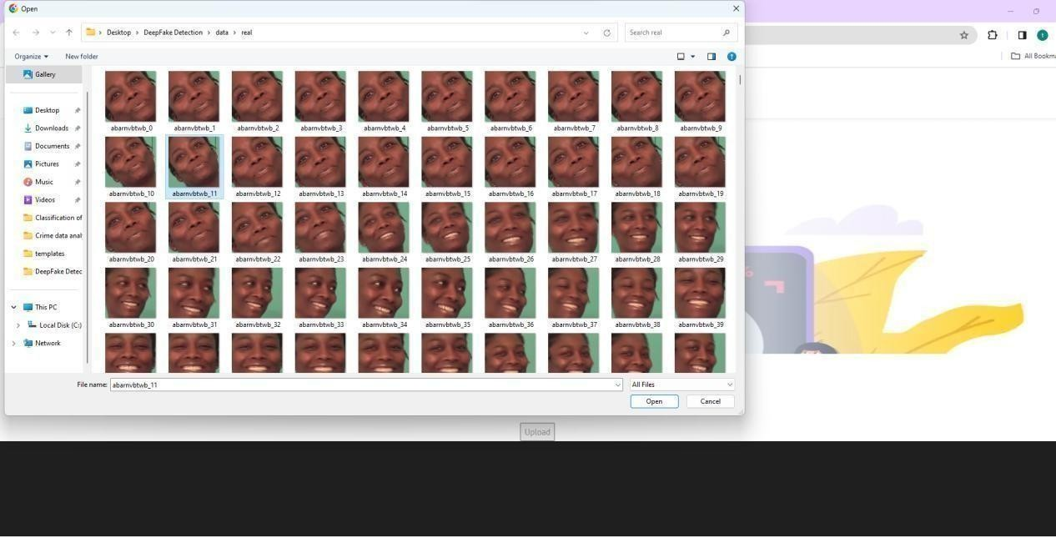

Fig-8.7 Select Video
STEP-8


Fig-8.8 Result for given input2

CONCLUSION
In conclusion, this study underscores the imperative to evolve deep fake detection systems amid the rising sophistication of manipulative technologies. The existing system, while exploring classic and contemporary methods, reveals limitations in adapting to emerging threats and understanding intricate patterns. Recognizing these shortcomings, the proposed system takes a proactive stance, integrating cutting-edge algorithms such as InceptionResnetV2 and Xception. The use of a Kaggle deep fake dataset ensures a diverse training ground, enhancing the system's adaptability to realworld scenarios. By prioritizing a holistic approach, the proposed system not only aims to improve detection accuracy but also strives to deepen insights into the production and distribution dynamics of deep fakes. This comprehensive understanding is crucial for effective countermeasures against the potential societal ramifications of manipulated content, including fake news, privacy violations, and impersonations. The proposed system stands as a pivotal step toward fortifying our digital landscape against the malevolent misuse of deep fake technology, contributing to a more secure and resilient digital environment for users worldwide.
The future scope of this research lies in continual advancements to counter emerging deep fake threats. Further exploration of innovative algorithms and the integration of evolving technologies, such as reinforcement learning, could enhance detection capabilities. Collaborative efforts across academia, industry, and policymakers are crucial to developing standardized protocols for deep fake detection. Additionally, ongoing research could delve into real-time detection systems and the integration of explainability features to increase transparency and user trust in deep fake detection technologies.

FUTURE ENHANCEMENTS

The future enhancements for the project "Automated Detection of Deep Fakes: A Deep Learning Approach" could include:

- Integration of Reinforcement Learning and Advanced AI Techniques: Incorporating reinforcement learning and other emerging AI methodologies to continuously improve detection models through adaptive learning and dynamic response to new deep fake generation techniques.
- Development of Real-Time Deep Fake Detection Systems: Creating highly efficient and lightweight models capable of detecting deep fakes in real-time, enabling immediate analysis and prevention of malicious content dissemination on social media and communication platforms.
- Incorporation of Explainable AI (XAI) for Transparency: Embedding explainability features into deep fake detection models to enhance user trust by providing clear insights into why a particular video or image is flagged as fake, thus improving transparency and accountability in detection systems.
- Expansion to Multi-Modal Deep Fake Detection: Extending the current research to cover multi- modal data (e.g., voice, text, and facial expressions combined), thereby increasing the robustness and accuracy of detection models against complex deep fakes that use multiple forms of manipulated content.
- Creation of Standardized Benchmark Datasets and Protocols: Contributing to the development of large-scale, diverse, and updated datasets along with standardized testing protocols to ensure consistent and fair evaluation of deep fake detection algorithms across different research initiatives.
- Collaborative Research with Industry and Policy Development: Fostering collaborative initiatives among academic researchers, industry experts, and policymakers to formulate guidelines, ethical frameworks, and legal regulations for the responsible use of AI in media, and to implement unified and legally binding deep fake detection mechanisms globally.

REFERENCES

- M. Mirza and S. Osindero, “Conditional generative adversarial nets,” arXiv preprint arXiv:1411.1784, 2014.
- Y. Bengio, P. Simard, and P. Frasconi, “Long short-term memory,” IEEE Trans. Neural Netw, vol. 5, pp. 157–166, 1994.
- I. Goodfellow, Y. Bengio, and A. Courville, Deep learning. MIT press, 2016.

- A. Sharma, E. Podoplelova, G.Shapovalov,A. Tselykh, “Adversarial Perturbations Fool Deepfake Detectors” IEEE Trans Signal Proces, vol. 45, pp. 2673–2681, 1997.
- K. Abbas, L.A. Tawalbeh,A. Rafiq, A. Muthanna, I.A. Elgendy,A. A. Abd “Google’s neural machine translation system: Bridging the gap between human and machine translation,” arXiv preprint arXiv:1609.08144, 2016.
- M. Schuster and K. Paliwal, “Networks bidirectional reccurent neural,” IEEE Trans Signal Proces, vol. 45, pp. 2673–2681, 1997.
- J. Hopfield et al., “Rigorous bounds on the storage capacity of the dilute hopfield model,” Proceedings of the National Academy of Sciences, vol. 79, pp. 2554–2558, 1982.
- Y. Wu, M. Schuster, Z. Chen, Q. V. Le, M. Norouzi, W. Macherey, M. Krikun, Y.
Cao, Q. Gao, K. Macherey, et al., “Google’s neural machine translation system: Bridging the gap between human and machine translation,” arXiv preprint arXiv:1609.08144, 2016.
- L. Nataraj, T. M. Mohammed, B. Manjunath, S. Chandrasekaran, A. Flenner, J. H. Bappy, and
A. K. Roy-Chowdhury, “Detecting gan generated fake images using cooccurrence matrices,” Electronic Imaging, vol. 2019, no. 5, pp. 532–1, 2019.
- H. A. Khalil and S. A. Maged, “Deepfakes creation and detection using deep learning,” in 2021 International Mobile, Intelligent, and Ubiquitous Computing Conference (MIUCC). IEEE, 2021, pp. 1–4.
- J. Luttrell, Z. Zhou, Y. Zhang, C. Zhang, P. Gong, B. Yang, and R. Li, “A deep transfer learning approach to fine-tuning facial recognition models,” in 2018 13th IEEE Conference on Industrial Electronics and Applications (ICIEA). IEEE, 2018, pp. 2671–2676.

- S. Tariq, S. Lee, H. Kim, Y. Shin, and S. S. Woo, “Detecting both machine and human created fake face images in the wild,” in Proceedings of the 2nd international workshop on multimedia privacy and security, 2018, pp. 81–87.
- N.-T. Do, I.-S. Na, and S.-H. Kim, “Forensics face detection from gans using convolutional neural network,” ISITC, vol. 2018, pp. 376–379, 2018.
- X. Xuan, B. Peng, W. Wang, and J. Dong, “On the generalization of gan image forensics,” in Chinese conference on biometric recognition. Springer, 2019, pp. 134–141.
- P. Yang, R. Ni, and Y. Zhao, “Recapture image forensics based on laplacian convolutional neural networks,” in International Workshop on Digital Watermarking. Springer, 2016, pp. 119– 128.
- B. Bayar and M. C. Stamm, “A deep learning approach to universal image manipulation detection using a new convolutional layer,” in Proceedings of the 4th ACM workshop on information hiding and multimedia security, 2016, pp. 5–10.
- T. Zhao, X. Xu, M. Xu, H. Ding, Y. Xiong, and W. Xia, “Learning selfconsistency for deepfake detection,” in Proceedings of the IEEE/CVF international conference on computer vision, 2021, pp. 15 023–15 033.
- D. Afchar, V. Nozick, J. Yamagishi, and I. Echizen, “Mesonet: a compact facial video forgery detection network,” in 2018 IEEE international workshop on information forensics and security (WIFS). IEEE, 2018, pp. 1–7.
- E. Sabir, J. Cheng, A. Jaiswal, W. AbdAlmageed, I. Masi, and P. Natarajan, “Recurrent convolutional strategies for face manipulation detection in videos,” Interfaces (GUI), vol. 3, no. 1,
pp. 80–87, 2019.
- Y. Li, M.-C. Chang, and S. Lyu, “In ictu oculi: Exposing ai created fake videos by detecting eye blinking,” in 2018 IEEE International workshop on information forensics and security (WIFS). IEEE, 2018, pp. 1–7.

